Artificial Intelligence Module 1.3: Self-Driving Cars
Activity 2: Label the Nuro R2 Sensors (Slide 16)

Match each sensor on the Nuro R2. Drag and drop the 6 labels on the right to the numbers on the car.

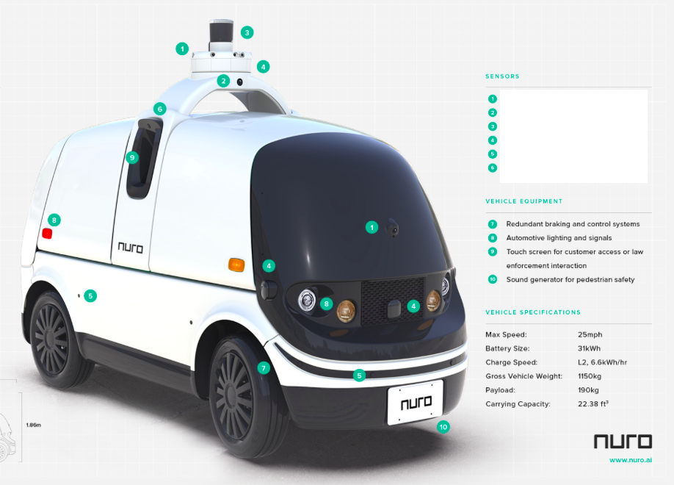

Activity 3: Summary and Reflection

- Choose 1 sensor from the chart. Predict what could go wrong if the sensor you chose were to malfunction and explain which of the other sensors could help the car to continue to navigate correctly/safely?

- In a paragraph reflect: Did learning about the sensors and subsystems of a self-driving car make you feel more or less comfortable with the technology? Why?

